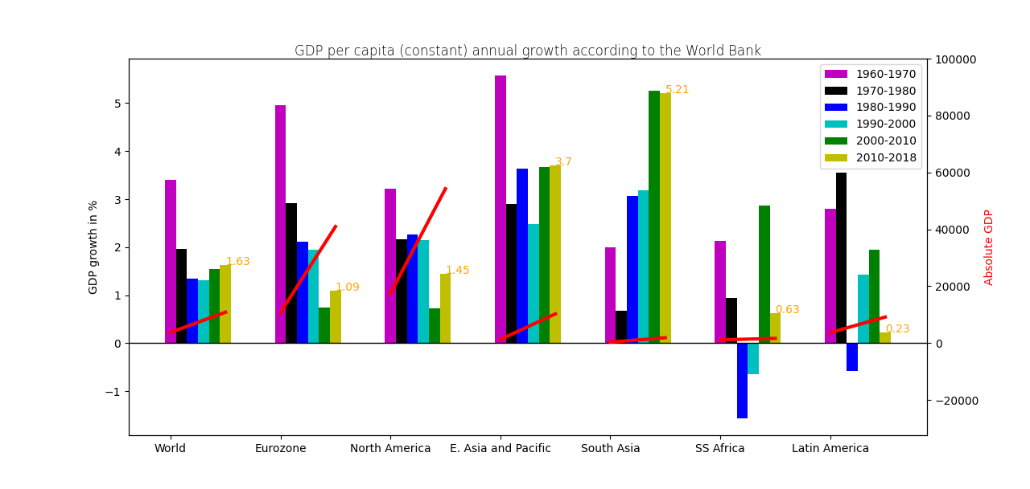

The graph displays the GDP per capita growth according to the World Bank data during the period of 1960-2018.

7 groups of bar colored charts represent the 6 regions of the world: Eurozone, North America, East Asia and Pacific, South Asia, Sub-Saharan Africa, Latin America. And the most left group displays the whole world GDP.

Each group consists of 6 bar charts, breaking down the analyzed period in 6 decades. The legend included to let you know what colored each sub-period has.

We can observe that the period of 60s-70s is characterized by high economic growth in Europe, North America, East Asia and Pacific. And the same can be said about the whole world: the decade of 60s-70s is the significantly more prosperous comparing to the next decades. On the other hand, in South Asia and Sub-Saharan Africa this period was not characterized by the highest growth rate.

We can also observe an economic recession in Sub-Saharan countries for 2 decades (1980-2000) and in Latin America in 80s.

As for the latest decade, it is characterized by higher GDP growth in Asian countries, while in Western part of the world the growth rate is significantly lower.

The highest GDP growth value relates to the period of 60s in Eastern Asia and Pacific, and it was 5.26%.

The second y-axis (on the right side) displays the absolute values of GDP in the same geographical zones, and the same time periods. The red line displays the trend of absolute GDP growth from 1960 to 2018. As far as we the data of the 2 years only, the lines are flat, and display the general tendency only, without intermediate values.

The data has been taken from the Wikipedia.

(source: <https://en.wikipedia.org/wiki/List_of_countries_by_GDP_(real)_per_capita_growth_rate> ).